iran
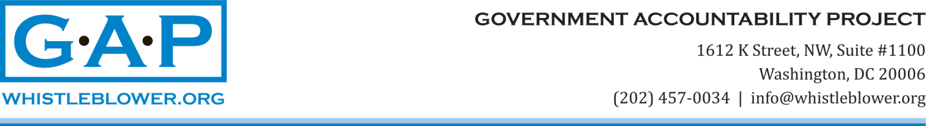

February 6. 2018

Zeid Ra’ad al Hussein, High Commissioner for Human Rights
OHCHR/United Nations
Palais des Nations, 1211 Genève,
Switzerland

Dear Mr. High Commissioner,

I received a response to GAP client Miranda Brown from Mr. Kyle Ward, Chief of Program Support and Management Services at OHCHR, last week, and was disappointed in the argument he outlined. GAP and Dr. Brown are especially baffled by his unilateral conclusion that “the matter [Dr. Brown’s whistleblower dispute with OHCHR] is considered closed” because here in Washington the matter is not considered closed at all.

Perhaps Mr. Ward is not informed of the intricacies of whistleblower disputes at the United Nations, as they are special administrative conflicts, not subject to resolution through the formal justice system, i.e., the administrative tribunals. This is the consequence of a ruling by the Appeals Tribunal in 2014 that resulted from the Secretary General’s appeal on of the favorable UNDT ruling in the Wasserstrom case. I want to note that the Secretary General appealed the favorable UNDT ruling in Wasserstrom on procedural grounds, the facts of the case remain undisputed. This appeal showed clearly that the former UN administration lacked the political will to protect whistleblowers.

This was unfortunate, but there it is.

In any case, best practice whistleblower protection statutes and policies mandate that whistleblower disputes be treated in much the same way as discrimination and harassment cases. These disputes involve an appeal for relief from what is often a concealed, imaginative and subtle form of persecution at work. No supervisor is ever going to announce – “I will now discriminate/retaliate against you.” Instead, a whistleblower (or discrimination target) is transferred summarily, demoted unexpectedly, or informed that her contract will not be renewed. In addition, training and travel may be denied, responsibilities stripped, privileges revoked, without apparent cause. Typically, these actions are taken by an official who is authorized to take them and who is either the retaliator himself or influenced by him.

In order to level the playing field in an inherently unfair adjudication process between an individual (such as Dr. Brown) and an institution (such as OHCHR/UN), GAP insisted that Ethics Office determinations be contingent on shifting burdens and standards of proof. This is best practice for resolving whistleblowers’ disputes. Significantly, the UN formal justice system does not include this adjustment of the burden of proof, yet, as a whistleblower, Dr. Brown was forced to appeal her transfer and non-renewal to the UNDT.

Therefore, the ruling of the UNDT is irrelevant to Dr. Brown’s claim of retaliation by blacklisting, and if considered relevant by Mr. Ward and by you, constitutes clear evidence that the United Nations neither respects nor implements best practice whistleblower protections.

All of which supports the need for a truly external review of Dr. Brown’s retaliation dispute by a qualified and disinterested third party.

US law has made the disbursement of the full US annual contribution to the United Nations contingent of the provision of external arbitration in whistleblower cases. The United Nations, does not, currently, anticipate such a process, and we are informed by a former spokesperson for the Secretary General’s Office that including such a process in the justice system would require a resolution of the General Assembly.

Moreover, in representing Dr. Brown, GAP has been informed by Member State delegations and UN officials about gossip and rumors among senior UN staff members and others regarding retaliation against her, and each time, what was reported to us was prejudicial to her. Many rumors include a bogus reference to this UNDT ruling, and we are beginning to suspect that the rumors are coming from the official quarters of the OHCHR.

If that is the case, please consider this communication to be a request that OHCHR cease and desist from propagating such derogatory assertions against Dr. Brown.

I look forward to your response to our request for external arbitration in order resolve Dr. Brown’s allegations of retaliation at OHCHR and blacklisting, in compliance with best practice whistleblower protection standards.

Yours truly,
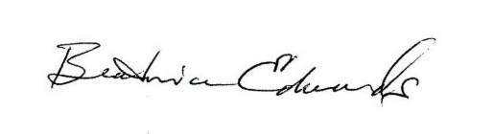
Beatrice Edwards
Senior International Policy Analyst

