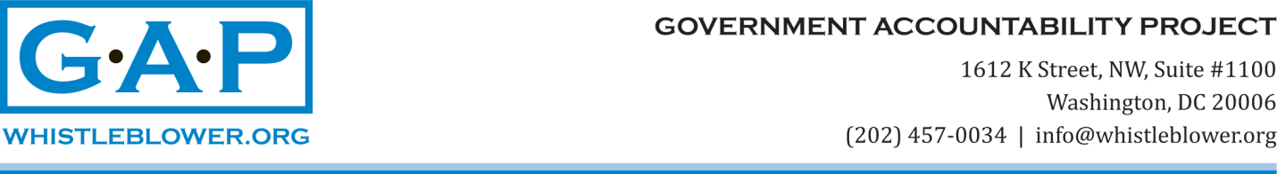

Zeid Ra'ad al-Hussein, High Commissioner for Human Rights
United Nations
Palais des Nations
1211 Geneva,
SWITZERLAND

7 November 2017
Dear Mr. High Commissioner:

I am writing to you on behalf of Emma Reilly, a client of the Government Accountability Project (GAP). As a staff member in the Office of the High Commissioner for Human Rights, Ms. Reilly reported what she reasonably believed (and continues to believe) is misconduct in February 2013. Following that disclosure, as you may be aware, she began to experience difficulties with her supervisor, the subject of her report, and she filed a retaliation complaint that is pending in the Ethics Office.

The response of OHCHR to Ms. Reilly’s disclosure seems now quite confused. We noted your letter to Human Rights Watch (HRW) regarding the HRW report on China. The letter asserts that OHCHR provides the governments of Member States (and specifically, China) only with information related to whether civil society representatives at a future session of the Human Rights Council represent a security threat. But Ms. Reilly alleges that the Chief of the Human Rights Council Branch orders his team to transmit the names of human rights defenders (HRDs) who have applied for accreditation for participation in HRC sessions. Indeed, OHCHR earlier admitted that names were transmitted to China, in both its press release of 2 February 2017, which implied the practice was ongoing, and in a letter to UN Watch of 30 May 2017, which stated the practice stopped in 2015.

We have also noted that the public statements about this issue made by OHCHR depend solely on information provided by those whose inappropriate reporting of HRDs’ names to the government of China Ms. Reilly disclosed. As a consequence, Ms. Reilly reiterates her request for a meeting with you to provide details about a practice that remains a concern.

At GAP, we understand that the Chinese HRDs whose names were transmitted to the Government prior to the HRC session they expected to attend are eager to correct the record. According to them, the OHCHR press release about this question was incorrect, and to date, no correction has been issued.

As Ms. Reilly’s legal representative, GAP is hopeful that relief from a retaliatory work environment will now be provided expediently. We are also hopeful that her appeals for protection and fairness will soon be addressed. On her behalf, the present letter requests an investigation into the press release of 2 February 2017 that impugns her integrity and inaccurately represents the actions of OHCHR with respect to the attendance of HRDs at HRC sessions.

Ms. Reilly continues to question whether it was within her supervisor’s discretion to reveal the names of HRDs to the Chinese government before an HRC session. Both she and GAP wonder if OHCHR considers that this action falls within the legitimate scope of authority of the Chief of the Human Rights Council Branch.

We therefore request that you meet with Ms. Reilly, investigate the practice she reported, and take steps to halt the retaliation against her. We also request that you ensure the contract renewal process, to which she will soon be subject, follow the same procedures as those applied to all other staff at her level in OHCHR.

We request that you, as the High Commissioner for Human Rights, help us to protect a whistleblower in your own office, whose career now appears to be in jeopardy as the result of making a good faith disclosure.

I look forward to a response at your earliest convenience.

Very truly yours,
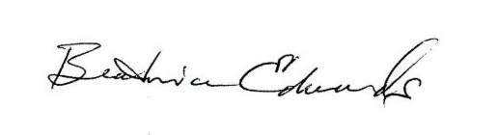

Beatrice Edwards
Senior International Policy Analyst

Cc: Ambassador Nikki Haley
Representative James McGovern
Representative Chris Smith
Representative Ileana Ros Lehtinen
Senator Patrick Leahy
Senator Bob Corker
Mr. Kenneth Roth

